### RRT Test Result

Map Size = 1000 x 562 pixel

Start (85,70)

Target(850,500)

Epsilon =10 , Max Search Tims =4000 Epsilon =50, Max Search Tims =4000

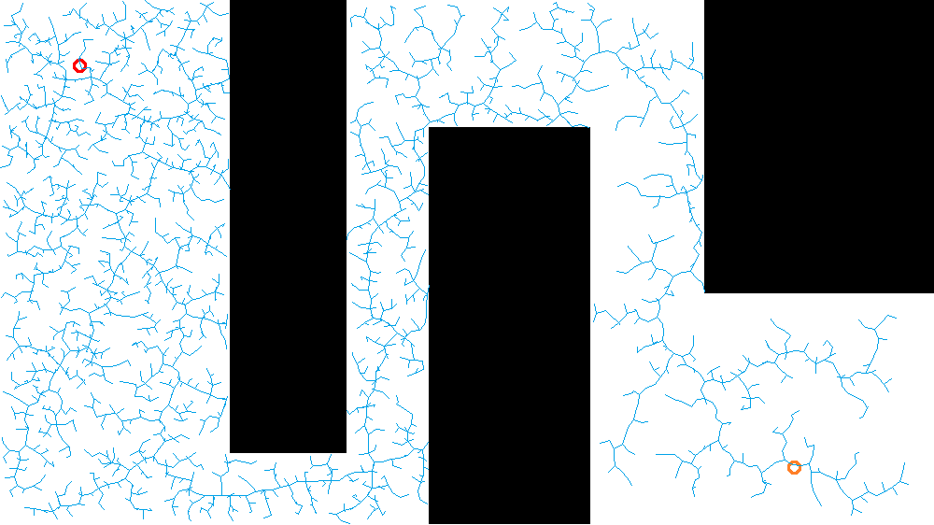 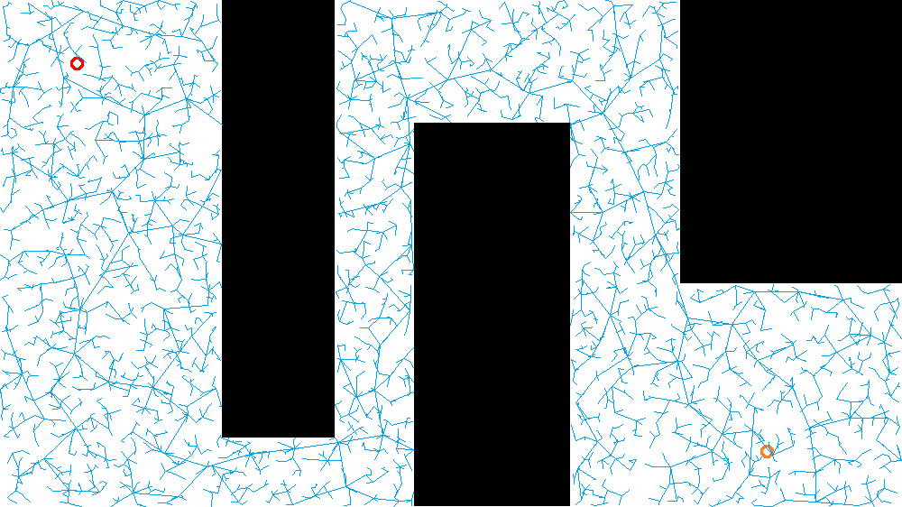

Epsilon =500 ,Max Search Tims =4000 Epsilon =1000 ,Max Search Tims =4000

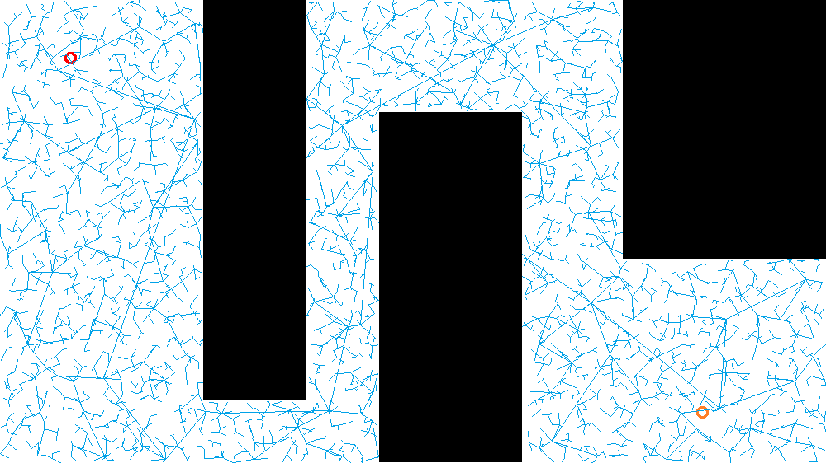 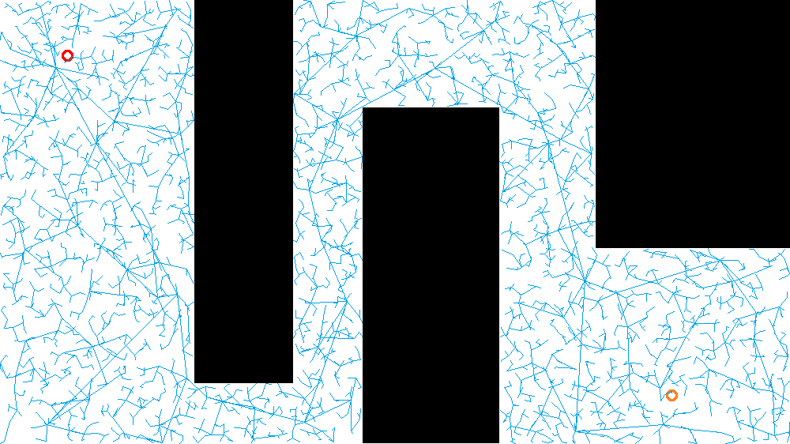

Epsilon =1000 ,Max Search Tims =500 Epsilon =2000 ,Max Search Tims =200

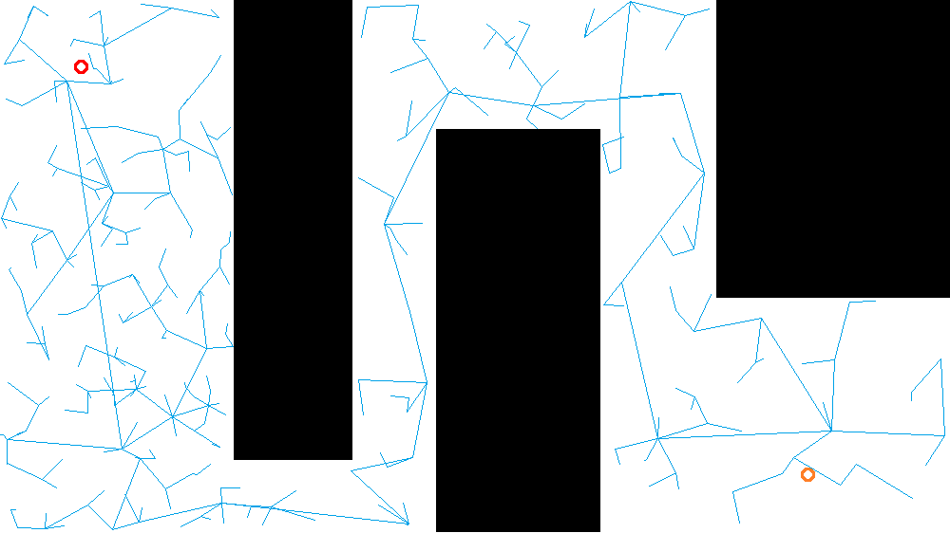 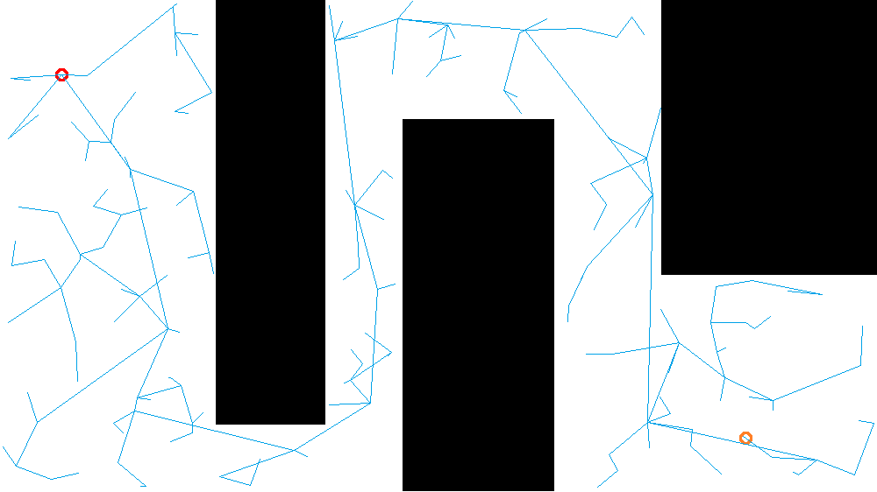

Original one smooth

 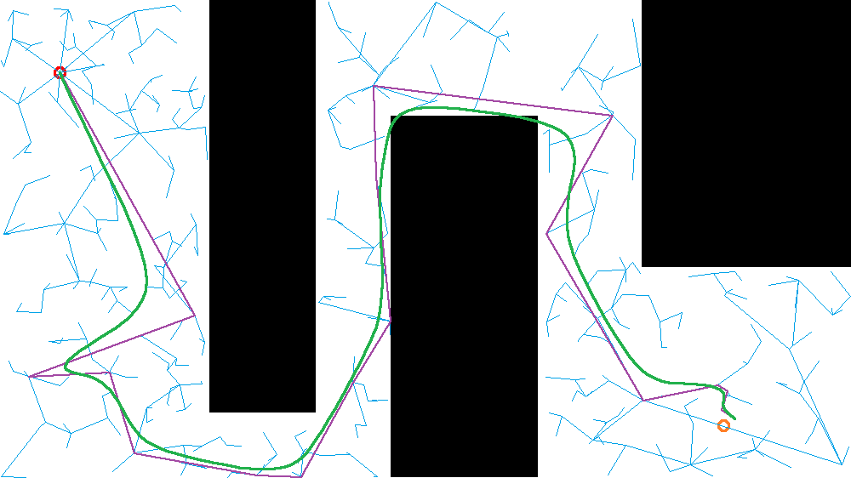

Overly smooth smooth with obstacle avoidance

